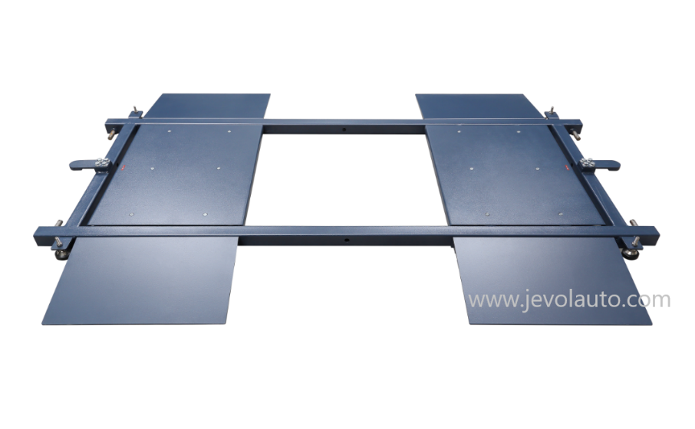**Mobile Sideslip Tester**

**Technical Parameters:**

|  |  |  |
| --- | --- | --- |
| **Items** | **Parameters** | |
| Model | RSS-500M | RSS-700M |
| Max axle load | 3T | 10T |
| Test speed | 5-10km/h | 5-10km/h |
| Range | ±15mm | ±15mm |
| Testing Plate Length | 500mm | 1000mm |

**Characteristics**

* High precise sideslip tester sensor ensures the accurate reach 0.1mm. Easy to use: only need to drive vehicle through the sideslip tester to check vehicle deviation.
* It can be displayed by Digital Display meter or Computer Control system software.
* Pre-check the vehicle toe-in in case of vehicle need wheel alignment saving your time.
* Check vehicle deviation, toe-in, speed and display on monitor vividly

# Option 1 for Console: Digital Display

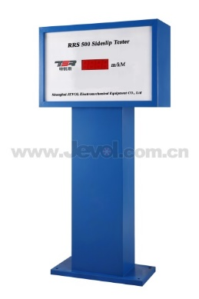

**With stable performance to show the testing result directly, print out the result with option micro-printer. The data can also be transferred to PC.**

# Option 1 for Console: Computer Control System

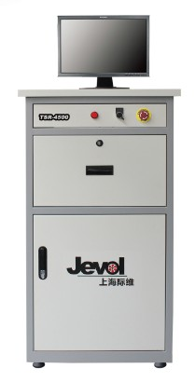

* Embedded industrial computer
* CPU：2.4G
* Memory: 1G
* Hard disk: 160G
* Monitor: LCD 19”
* Industrial computer has high anti-interference and anti-vibration performance. With good heat dissipation performance and long life time.

# 1Jevol TSR Software